**Travel Agency flight-Booking System**

**Problem Definition and Background**

With the increasing number of flight bookings each year , it is necessary for a travel agency to have a flight booking system which would help them add or manage airlines . In addition to this, it is essential for them to define a set of parameters for managing airlines , managing and updating flight details from airlines and managing customer booking details accordingly. This parameters should be constructed on travel agency’s concern like ‘how efficient a system is to allow addition and updating airlines ?’ , ‘Can tickets be updated?’ ‘is the option to view recent booking available?’ , ‘How good is the system to avoid booking of the same customer’. In addition to managing the traffic of flights, the travel agency itself should be able to search on customized source and destination flights and then carry out booking or cancel out booking accordingly.

**Proposed Solution**

* We target to construct Travel Agency Flight Management solution using software engineering techniques for enhancing the management system for Travel agency and accordingly design and implement its functionality.
* The Travel Agency Flight Management solution will enable Travel agency to add Airline Directory from which it wishes to support its business and take flight details from airlines accordingly.
* The Travel agency should be able to add/update/delete multiple airlines and also add/update/cancel flights from airlines in terms of availability of flights from airliner
* Our end goal is to implement such Flight-Customer management system from Travel Agency prospective with support for airline management and Flight details management, customer details management and seat management.

**UML DIAGRAM FOR EXPANDED MODEL :**

**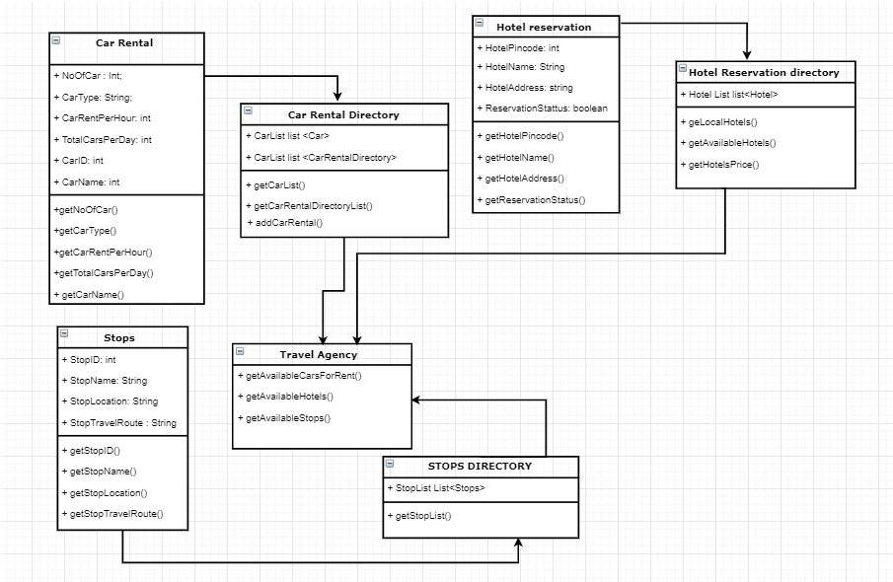  
  
JAVA IMPLEMENTATION :**Business Classes :

* CarRental
* CarRentalDirectory
* HotelReservation
* HotelReservationDirectory
* Stops
* StopsDirectory
* TravelAgency